Sars-CoV-2 (COVID-19) Pandemic:
Practice Guidelines for Birth Workers
Updated 31 March 2020

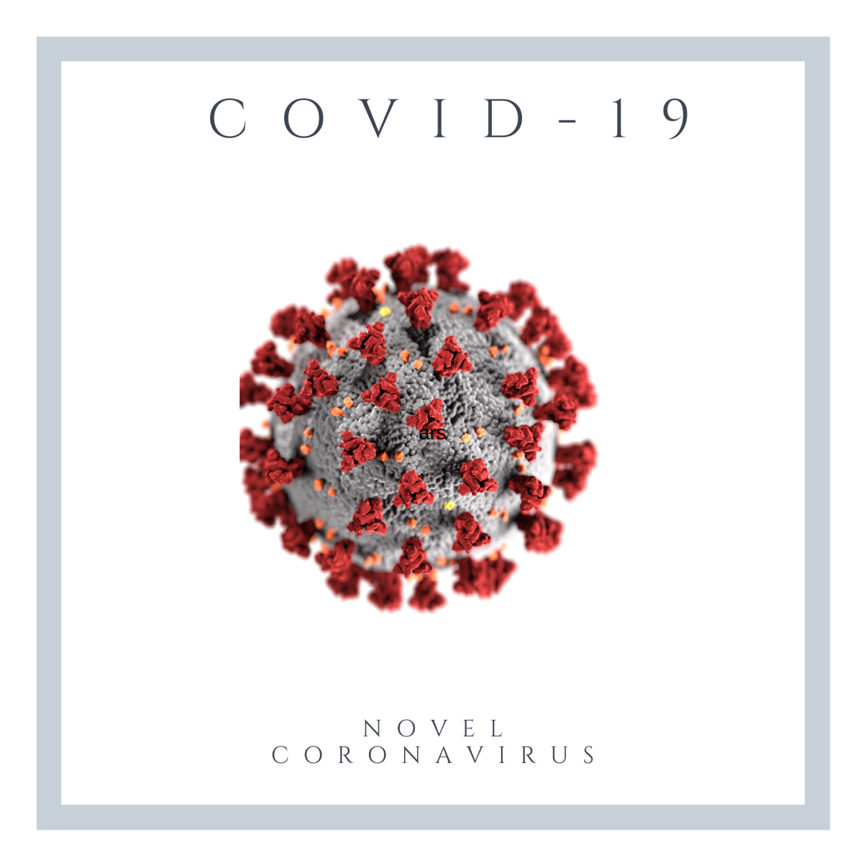

Table of Contents:
Introduction and Symptom Chart | Page 3-4
Health Care Personnel: Protecting Yourselves and your clients | Pages 5-9
Clinical Visit Scheduling Guidelines and Home Visits | Pages 10-11
Staff illness and exposure | Page 12
Client education and protection and Screening | Page 13-14
Facility controls | Page 15
Special consideration: Pregnancy | Page 16
Special consideration: Waterbirth | Pages 17-18
Special consideration: Postnatal period | Page 19
Special consideration: Breastfeeding and COVID-19 positive women | Pages 20-21
Sources of Information/References | Pages 22-25
Appendix A: Definitions and Acronyms | Pages 26-27
Appendix B: Rational use of personal protective equipment (PPE) for coronavirus disease (COVID-19) WHO (2020) | Page 28-30
Appendix C: CDC Interim U.S. Guidance for Risk Assessment and Public Health Management of Healthcare Personnel with Potential Exposure in a Healthcare Setting to Patients with Coronavirus Disease (COVID-19) | Pages 31-33
Appendix D: Criteria for Return to Work for Healthcare Personnel with Confirmed or Suspected COVID-19 (Interim Guidance) | Page 34
Appendix F: Other considerations for masks and PPE - Reusing and Sterilization: | Pages 35-36

Note: The following guidelines are suggestions based on the best, current evidence. Please follow your local Ministry or Department of Health’s recommendations if and when available. This is a working document and will be updated as new evidence and information becomes available.

Sars-CoV-2, also known as COVID-19 or Coronavirus, is a viral respiratory infection that is highly contagious and primarily transmitted person to person via respiratory droplets and contact routes. It is most commonly spread directly by being in close contact (within 6 feet) with an infected person when they cough or sneeze. Evidence suggests that it may be spread indirectly via airborne transmission in certain circumstances and settings, and/or via contact with a contaminated surface. Preliminary data indicates that the virus can survive on a variety of surfaces for 24-72 hours.

Although the virus has been identified in other body fluids it is unknown if the virus can be transmitted via those fluids. While viable, infectious SARS-CoV-2 has been isolated from respiratory, blood, urine, and stool specimens, it is not yet known whether the virus can be identified in other non-respiratory body fluids from an infected person including vomit, breast milk, vaginal secretions or semen. It remains unknown whether a pregnant woman with COVID-19 can transmit the virus to her fetus or baby during pregnancy and/or delivery. There is no evidence yet of the virus having been found in samples of amniotic fluid or breastmilk. Virus specific antibodies have been found in neonatal blood serum samples.

The symptoms associated with COVID-19 can range from mild to severe. There have been cases of asymptomatic COVID-19 but it is unknown whether an individual who is asymptomatic can transmit the virus. The role of pre-symptomatic transmission (infection detection during the incubation period prior to illness onset) is also unknown. However, it should be assumed that both asymptomatic and pre-symptomatic persons can transmit the virus and precautionary measures to reduce transmission should be taken. It is not yet known if a person can be infected more than once. It is currently unknown how long a person can remain infectious. The onset and duration of viral shedding and period of infectiousness for COVID-19 are not yet known.

The clinical spectrum of COVID-19 ranges from mild disease with non-specific signs and symptoms of acute respiratory illness, to severe pneumonia with respiratory failure and septic shock. Because there have been reports of asymptomatic infection with COVID-19, it is difficult to know for certain whether someone is a carrier and/or vector of the disease.

Because COVID-19 is a novel virus, there is a lot of information that is not yet known. The pandemic situation has progressed rapidly and information about the virus changes quickly. As a result, it is difficult to know what the best and safest practices are to protect ourselves and the women and families that midwives and other health care workers (HCWs) care for. It is important to be flexible during this time and to make the best decisions for the care of your community based on the most current information. We will continue to update these guidelines as more information becomes available.

Symptomatic Differences between Covid-19, Influenza, and the Common Cold

Covid-19 Influenza Common Cold
Incubation Period | 2-14 days (median 5 days) | 1-4 days | 1-3 days
Symptom Onset | Gradual or abrupt | Abrupt | Gradual
Fever (>100.4F or 38C) | Common | Common | Rare
Cough | Common | Common | Mild to moderate
Fatigue | Common | Common | Sometimes
Runny Nose | Sometimes | Common | Common
Nasal Congestion | Sometimes | Sometimes | Common
Diarrhea | Sometimes | Sometimes | Rare
Body Aches | Sometimes | Common | Slight
Sore Throat | Sometimes | Sometimes | Common
Headache | Sometimes | Common | Rare
Loss of Appetite | Sometimes | Common | Sometimes
Shortness of Breath | Common | Sometimes | Mild
Respiratory Issues | Common | Sometimes | Sometimes

Health Care Personnel: Protecting Yourselves and Your Clients:
The following guidelines are standard measures and precautions that you should take to protect yourself and your clients from the risk of exposure and infection.
- Universal precautions should always be followed;
- Hand washing is the first line of defense:
  - Wash hands thoroughly with soap and water for a minimum of 20-30 seconds;
  - If soap and water are unavailable, use an alcohol-based sanitizer with at least 60% alcohol, covering all surfaces of your hands and rubbing them together until they feel dry;
  - Wash hands before and after making physical contact a client.
- Avoid touching your eyes, nose, and mouth, especially with unwashed hands;
- Staff and Midwife Clothing/Uniform Recommendations:
  - All staff and midwives should wear clean scrubs provided by the birth center or clinic instead of clean street clothes.
  - Home birth midwives should have separate clothes and/or scrubs that can be removed prior to returning home;
  - Remove clothing with prior to leaving the clinic, birth center, and/or client’s home;
    - Remove clothing in a room that can be isolated and cleaned thoroughly and place clothing in a designated bin or container for infectious laundry.
    - Treat all clothes as infectious and use universal precautions when handling them even when caring for asymptomatic clients.
- ALL staff, midwives, and clients should be screened for current and recent COVID-19 symptoms;
  - Temperature Check;
  - Ask person if they have, or have recently had fever, cough, diarrhea (or another digestive upset);
- Adhere to strict social distance requirements;
  - Maintain a distance of 6 feet from clients;
  - Avoid shaking hands, hugging, or making any type of physical contact with clients except for what is essential for necessary procedures;
  - Minimize the amount of time spent in close contact;
  - Clients should not wait in waiting rooms. Clients need to wait outside and/or in their personal vehicles when possible and wait to be called into the clinic and/or birth center for an appointment;
- Personal Protective Equipment (PPE):
  - Wear all appropriate and necessary PPE when visiting and/or treating clients including as indicated for a procedure;
  - While there is an ongoing shortage of PPE, PPE should always be used when indicated and when available:
  - HCWs should wear a surgical mask and gloves when caring for asymptomatic clients during any and all contact. It is also recommended that even asymptomatic clients be given a mask to wear during all clinical visits.
  - Full PPE including gown, gloves, masks that cover both mouth and nose, and eye protection is required for labor, delivery and immediate postpartum period. Double gloving will also assure safer doffing technique.
N95 masks are only recommended for aerosolizing procedures and are not necessary for all procedures. Standard surgical masks are considered adequate protection from airborne respiratory droplets. Refer to Appendix F on other considerations for masks and PPE.
  - As the result of PPE shortages, the use of homemade masks has been recommended for certain circumstances and will offer some protection for HCWs and clients. There is no evidence to support the use of homemade masks in protecting against COVID-19 transmission but may reduce the likelihood of transmission and/or infection.
    - “A protective mask may reduce the likelihood of infection, but it will not eliminate the risk, particularly when a disease has more than 1 route of transmission. Thus, any mask, no matter how efficient at filtration or how good the seal, will have minimal effect if it is not used in conjunction with other preventative measures, such as isolation of infected cases, immunization, good respiratory etiquette, and regular hand hygiene. An improvised face mask should be viewed as the last possible alternative if a supply of commercial face masks is not available, irrespective of the disease against which it may be required for protection” (Davies, 2013).
- COVID-19 symptoms can present quickly and any patient that has presented with any symptom(s) or develops any symptom(s) during your visit or while in your care should immediately be given a mask and transferred to another facility or placed in a separate room to minimize risk of exposure and infection to other staff and clients.

Homemade Masks vs Surgical Mask:
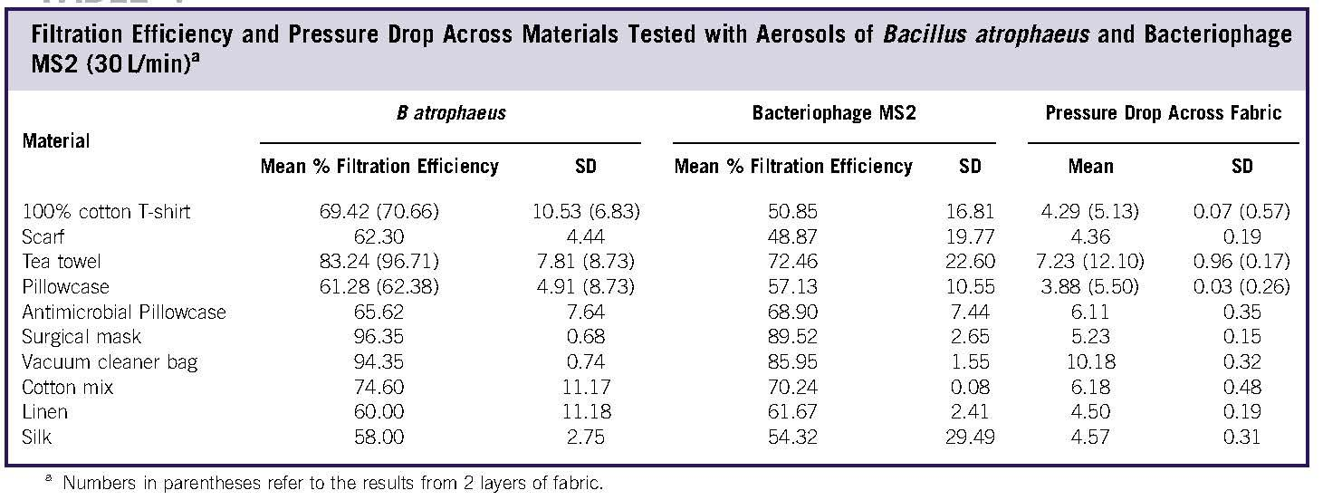

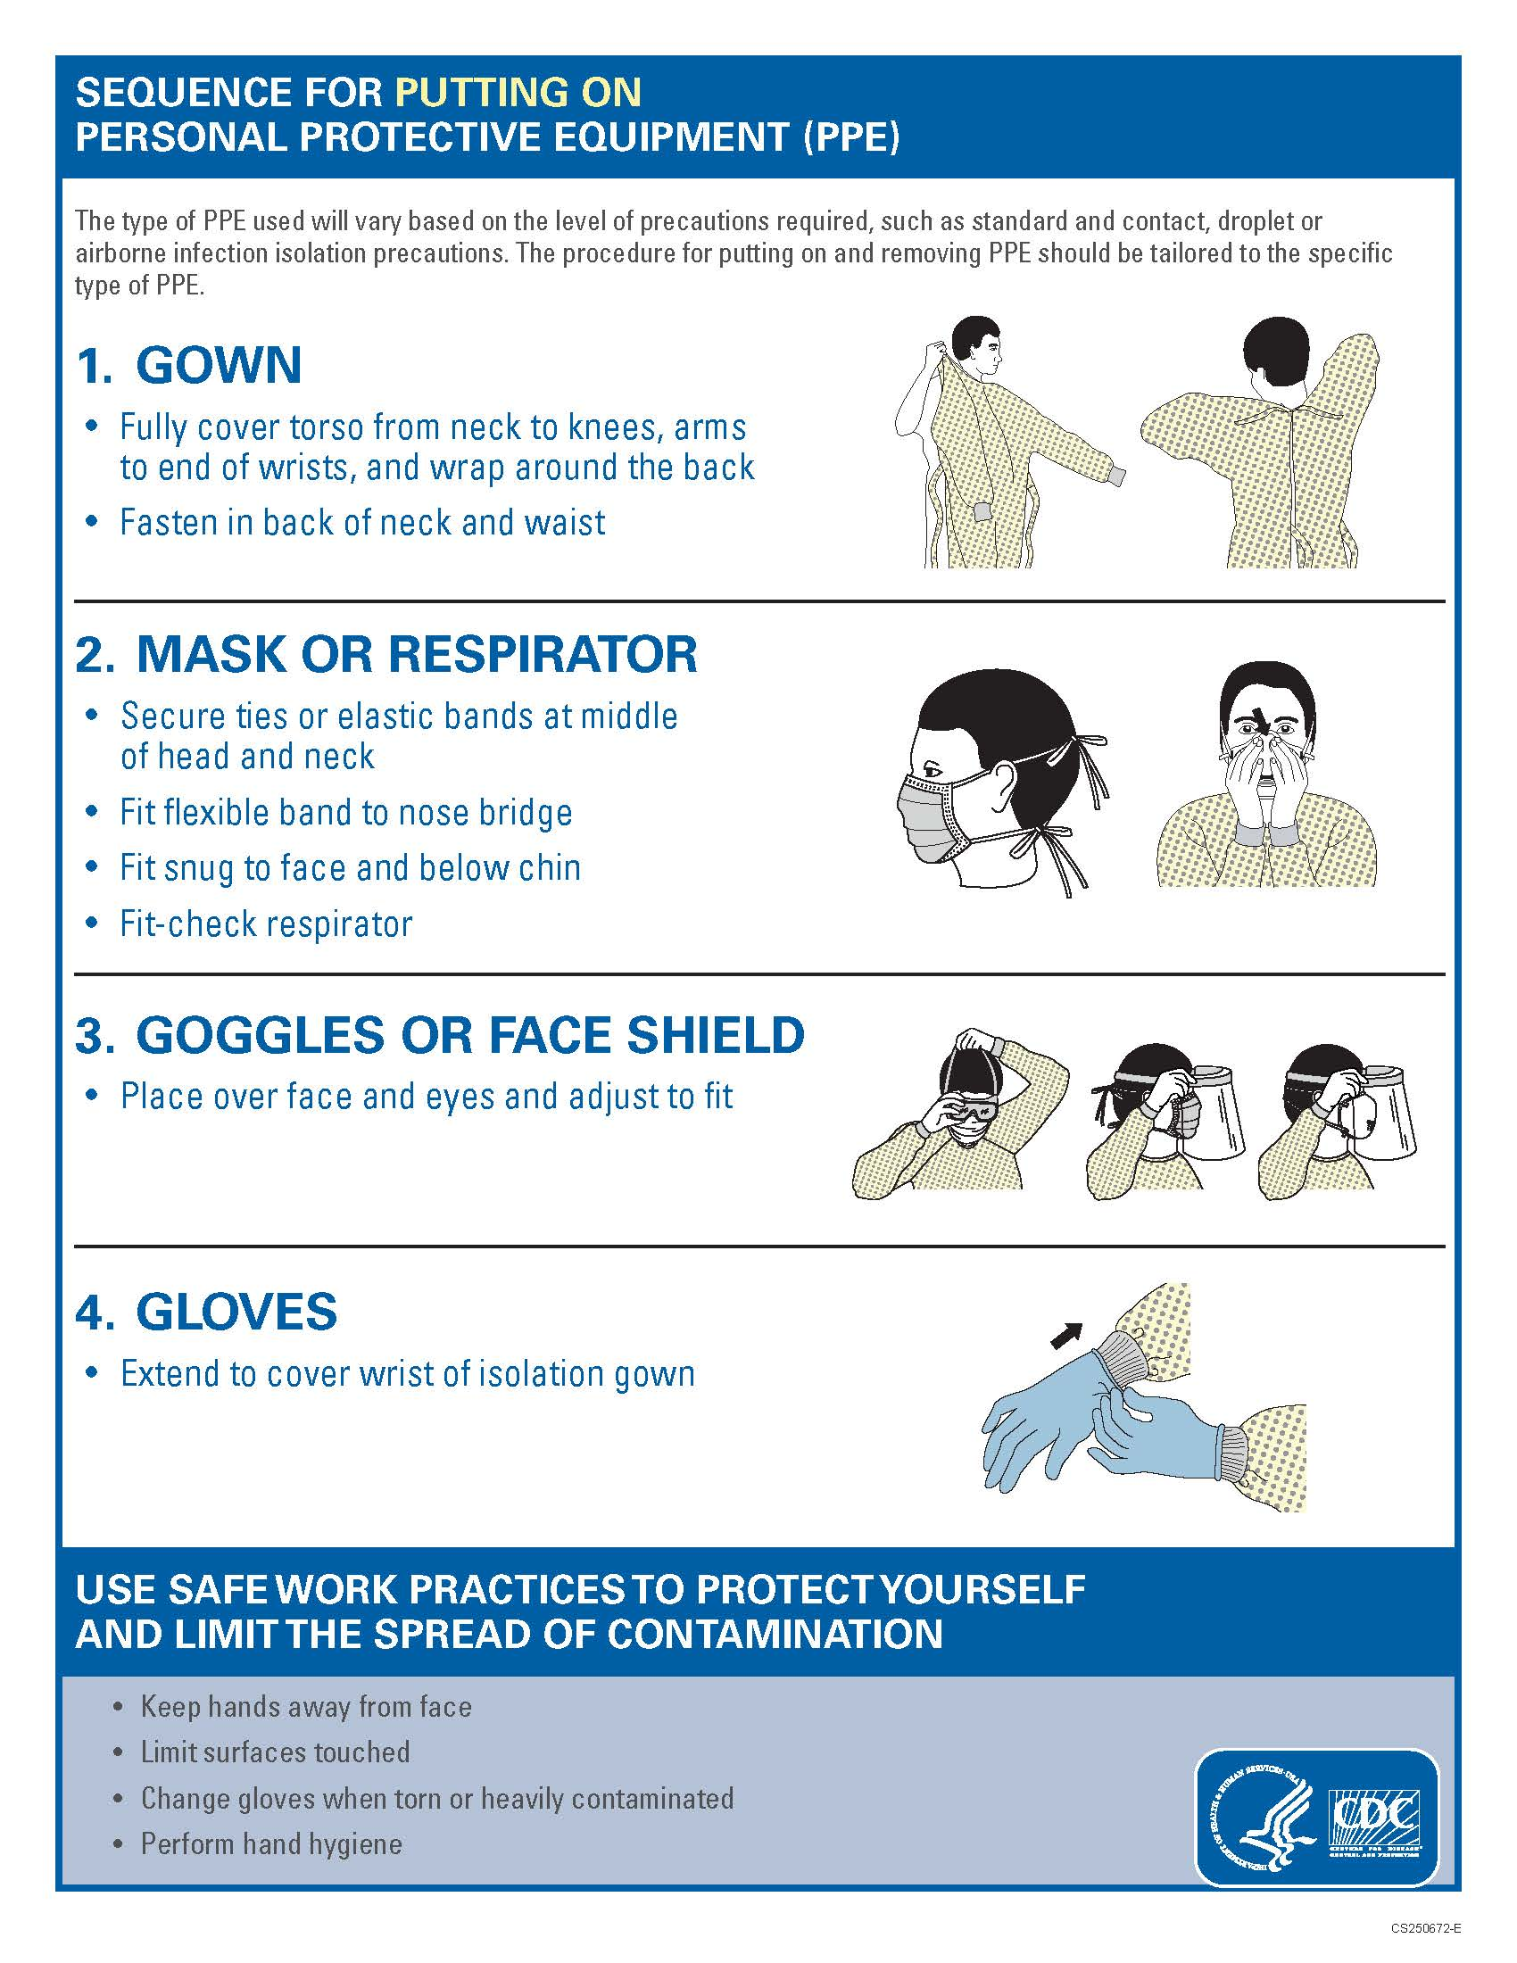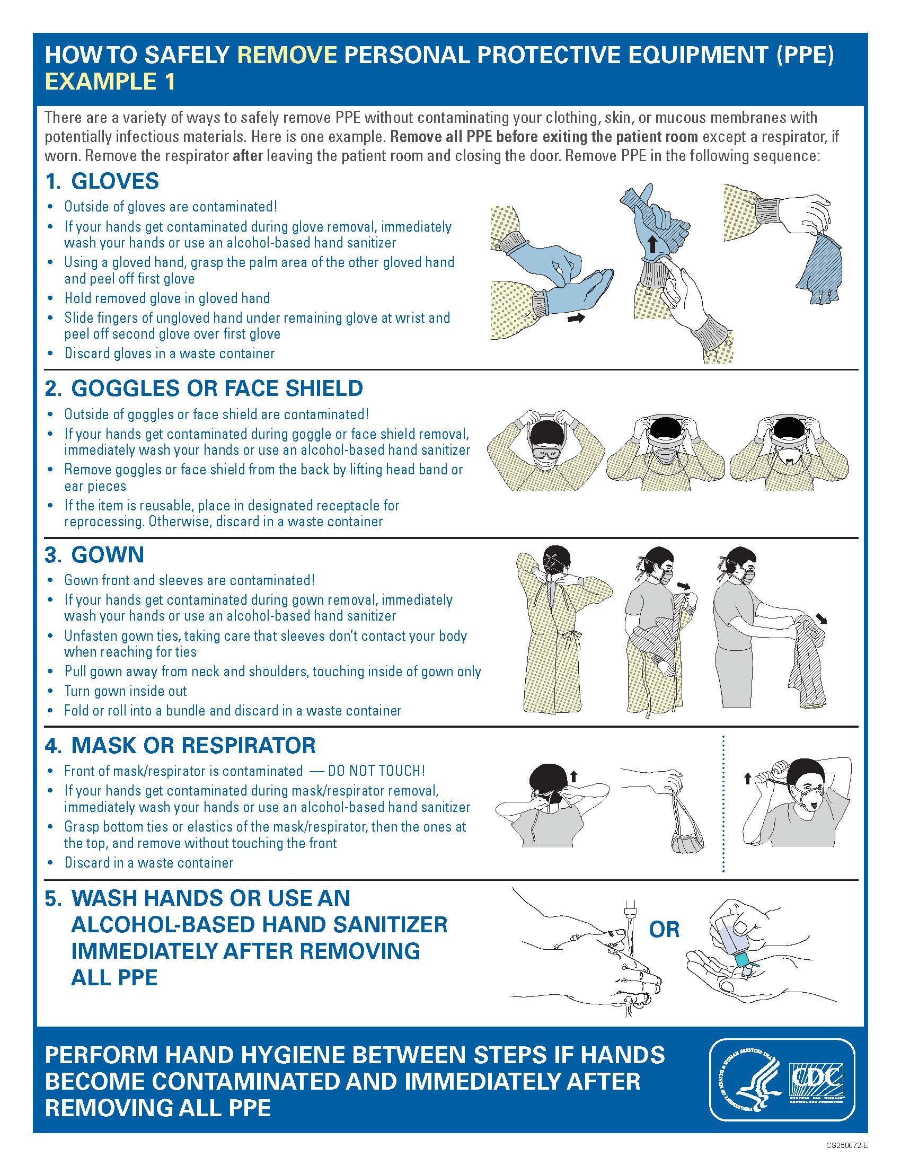
Clinical Visit Scheduling Guidelines
- All non-essential visits should be rescheduled until the pandemic is under control and social distancing requirements have been lifted;
  - Well-woman visits;
    - Postpone all non-essential well-woman visits; or
    - Conduct a well-woman consultation via telehealth utilizing Zoom, or another secure video conferencing platform;
  - Prenatal visits;
    - Extend the length of time between appointments and skip non-essential appointments;
    - Conduct check-ins for non-essential appointments via telehealth utilizing Zoom, or another secure video conferencing platform;
  - New client intake visits;
    - Complete remotely via telehealth unless the patient presents with an urgent problem and requires an urgent in-person visit;
- All in-person visits should be focused only on physical assessments and the length of these visits should be minimized;
- Telehealth should be used for all non-essential visits and/or other consultations, questions, client education, etc.
- The client should be asked to attend the visit alone. Current recommendations to reduce the risk of exposure and infection include not allowing family members, including children, friends, or other support persons to accompany a client to an appointment;
- Individuals accompanying a client to the birth center and/or clinic and for home deliveries should be limited during labor, birth, and the immediate postpartum period. The current recommendations suggest 1 household member such as a spouse/partner and 1 support person such as a doula;
  - It is recommended that children not be allowed into the birth center or clinic for any reason;
- For home birth clients, it is important that children have a designated caregiver in another room or part of the home who is completely asymptomatic. It is advised that children are not to touch and/or be around any equipment or supplies that the midwife brings into the home.
- Cancel all scheduled in-person classes, groups, or other group gatherings;
  - Some classes, groups, and group gatherings may be organized remotely.

Suggested in-person Visit Schedule (AOM) based on WHO recommendations:
First Trimester | One visit
Second Trimester | 16-20 weeks | 28 weeks
Third trimester | 31-32 weeks | 34-36 weeks | 38 weeks | 40 weeks | 41 wees
Postnatal | Within 48 hours of birth
If your client’s clinical circumstances require in-person assessment (e.g., weight or feeding concerns, unwell infant, concerning jaundice, secondary PPH, postpartum infections etc.) make arrangements to visit following appropriate health precautions. Offer additional visits, including the discharge visit virtually: by phone or videoconference.

ACOG Suggested Schedule of Prenatal and Postnatal Visits:
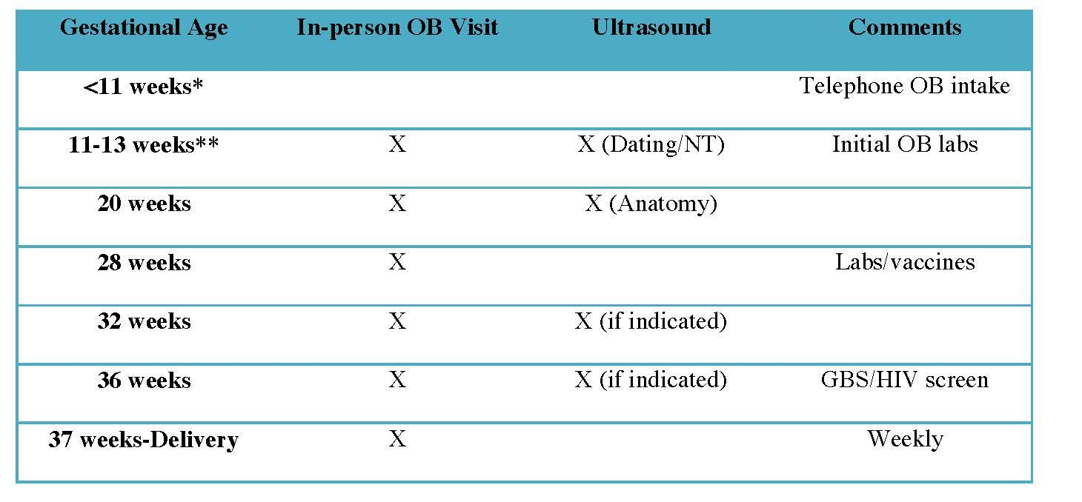
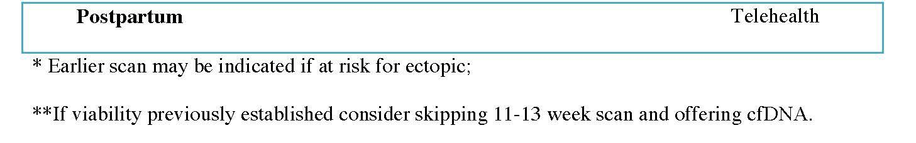
Notes:
Note: Research demonstrates there is no significant difference in outcomes for those who receive 8 contact visits for prenatal care versus those who receive more than 8 contact visits (WHO). Some of these contact visits should be conducted remotely when possible.

Home Visits
Home visits should be performed only as necessary and be conducted via telehealth when possible. If a contact visit needs to be made, request the client and/or her newborn visit the clinic only if asymptomatic. If a client presents with symptoms, a visit may be conducted in the individual’s personal vehicle or an alternative visit may be arranged. Full PPE and precautions should be taken.
- The number of home visits should be minimized;
- Personnel conducting home visits should contact the client prior to the scheduled visit and inquire about any household members who have demonstrated any symptoms within a 2-week period of time, have been exposed to someone who tested positive for COVID-19, or are under any type of quarantine;
  - If anyone in the household, including the client, is symptomatic or has had symptoms within a 2-week period of time, then a home visit should not be conducted.
- If there is any concern related to care, clients should come to the clinic to be seen for an in-person visit and a home visit should be avoided;
- Personnel should employ universal precautions and use appropriate PPE for ALL home visits, even if the patient and their family are asymptomatic.
- Newborn visits should be maximized to ensure all physical assessments and testing are completed at the same time to minimize the need for additional visits;
- Newborn visits should be conducted in the clinic if an in-person visit is required.

Staff Exposure and Illness
- All staff should be screened for the following symptoms upon arrival to the clinic, birth center, and/or home:
  - Fever
  - Cough
  - Digestive upset
  - Any respiratory symptoms
- Home birth midwives are required to self-assess daily for signs or symptoms of fever, any respiratory symptoms, and digestive upset;
- All personnel with ANY symptom of an upper respiratory infection (URI) or influenza should NOT come to work or participate in the care of clients. They should be required to self-isolate at home and check with their local, state, or country health department for any necessary testing and guidance on when it is safe to return to work;
- All personnel exposed to a symptomatic and/or COVID-19 positive client need to refer to Appendix C for the CDC’s recommendations or to your local health department or ministry of health for guidance;
- Refer to Appendix D for the CDC’s Criteria for Return to Work for Healthcare Personnel with Confirmed or Suspected COVID-19 (Interim Guidance) or follow your local health department or ministry of health recommendations and mandates.

Client Education and Protection
- Educate and instruct the client on current social distancing guidelines and recommendations;
- Educate and instruct the client on proper handwashing techniques and respiratory hygiene (i.e. how to properly cover a cough);
- Clients should be informed of the symptoms of COVID-19 and when to call their primary care provider and/or midwife;
- Instruct clients to call ahead if they have a scheduled appointment and are symptomatic;
- Instruct clients on the proper use of PPE such as masks and gloves and enforce the proper use of these items.

Screening for Signs/Symptoms of COVID-19
- All staff, midwives, personnel, clients, and client household/family members should be screened before all visits;
- Screen for the following:
  - Any signs and/or symptoms of respiratory infection:
    - Fever
    - Cough
    - Shortness of breath
  - Any known or suspected exposure to confirmed and/or suspected COVID-19 positive patient;
  - Other signs and/or symptoms considered suspicious for COVID-19, including but not limited to:
    - Diarrhea
    - Vomiting
    - Fatigue
- If a midwife suspects COVID-19 and is transferring care to another facility, the appropriate department of that facility should be notified prior to the client’s arrival to ensure the facility has time to take appropriate infection control steps;
- All symptomatic patients and associated persons should be assumed COVID-19 positive, even in the absence of confirmation via diagnostic testing;
  - All symptomatic persons should not be allowed into the birth center and/or clinic unless isolation rooms and all appropriate PPE and staff are available;
  - All in-person and in-home care for home birth clients should be suspended if the client and/or anyone in their household is symptomatic;
- Providing care to a symptomatic client should be avoided unless you have appropriate PPE and have been trained in proper PPE techniques. Refer to Appendix B for World Health Organization (WHO) PPE Guidelines for Conserving PPE and Proper Protection.

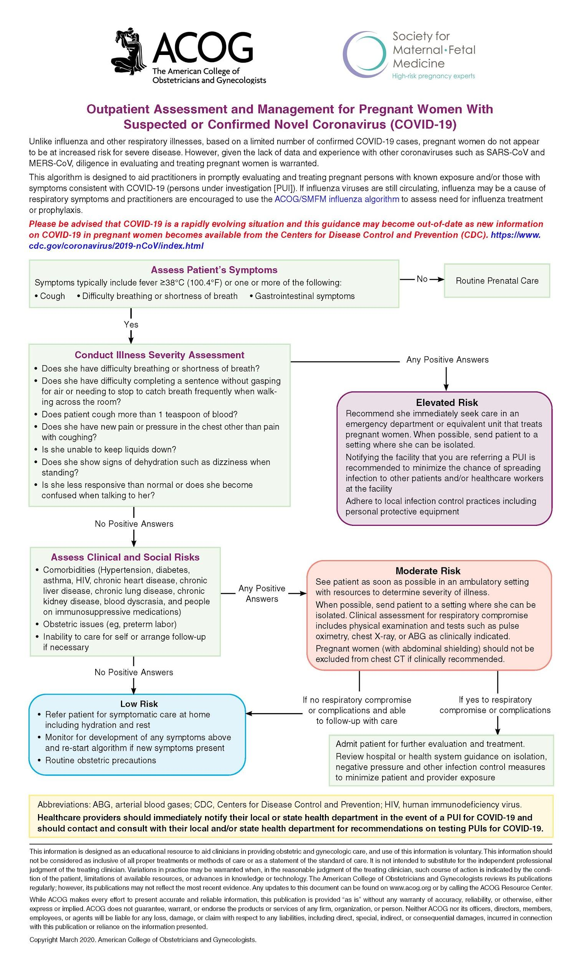
Facility Controls
- Maintain social distancing of at least 6-feet from all other staff members and patients;
- Waiting rooms should not be utilized;
  - Clients presenting for scheduled appointments should wait in their personal vehicle or outside until called for their appointment;
    - Clients should be instructed to maintain proper social distancing (6-feet) from all other clients and staff while waiting for their appointment;
- A staff member should be placed at the entrance to the birth center and/or clinic in full PPE and screen every client and/or individual who visits the clinic;
  - Symptomatic persons should be asked to leave, and their appointment should be rescheduled;
- Masks should be available in client areas and provided to anyone with respiratory symptoms;
  - Clients with respiratory symptoms should be immediately given a mask and instructed on the proper use of the mask;
- If available, hand sanitizer should be placed in each exam room, waiting room, front desk, and in any other public area;
- Handwashing is preferable and recommended but hand sanitizer is an acceptable alternative as long as it has at least 60% alcohol;
- Designate a specific room for the screening of any symptomatic clients;
  - Avoid waiting and other common areas;
  - Use a separate entrance if possible;
  - Close the door;
  - Thoroughly clean the room and all spaces in which the client presented after the encounter.

Social Distancing during Staff Meeting at FreMo Medical and Birth Centre, Kawangware, Nairobi, Kenya

Special Considerations: Pregnancy
It is currently not known whether pregnant persons are at an increased risk of infection from COVID-19 than the general public or whether they are more likely to develop serious and/or critical illness as a result of infection. Pregnant persons in general are at an increased risk for contracting viral infection as the result of normal immunologic and physiologic changes that occur during pregnancy. Pregnancy can have systemic effects that increase the risk for complications from respiratory infections but there is no available data that confirms this for COVID-19. Pregnant women in general are considered a vulnerable and at-risk population. Therefore, the WHO recommends that pregnant persons with symptoms of COVID-19 should be prioritized for testing and if they test positive, they may require specialized care. It should be assumed that pregnant persons are at an increased risk for contracting COVID-19 and developing serious and/or critical illness until proven otherwise.

Pregnant persons with probable, suspected, and/or confirmed COVID-19 infection should have access to woman-centered, respectful, skilled care including obstetric, fetal medicine and neonatal care, and mental health/psychosocial support with readiness to care for maternal and neonatal complications.

All pregnant persons currently infected or recovering from COVID-19 should be provided with counseling and all necessary information related to the potential risk of adverse pregnancy outcomes. The individual’s choices and rights to sexual and reproductive health care should be respected regardless of COVID-19 status, including access to contraception and safe abortion to the full extent of the law.

There is no available evidence that indicates COVID-19 infection places a pregnant person at an increased risk for pregnancy and/or birth complications. There are reports of premature rupture of membranes (PROM), preterm birth, intrauterine growth restriction (IUGR), and fetal distress during labor in cases where the pregnant person was positive for COVID-19. However, it is not known whether these outcomes were a direct result of the infection.

It is not yet known whether a pregnant person infected with COVID-19 can pass the virus to the fetus during pregnancy or to the baby during birth. There have been viral antibodies detected in the blood serum of infants born to a COVID-19 positive parent, but no documented cases of vertical transmission. However, the possibility of vertical transmission cannot be ruled out. It is possible that the infant may contract the virus after the birth and all necessary precautions should be made to reduce exposure and prevent infection.

Special Considerations: Waterbirth
There is a lot of controversy surrounding the safety of waterbirth given all the unknowns of SARS-CoV-2. We are all questioning whether normal protocols and practice guidelines are pertinent and our understanding of what safe and appropriate care is being challenged during this pandemic. To date, there are still more questions than answers and guidelines are based on our best understanding of the situation.

We do know the benefits of laboring in water (including showers and submersion in a tub) are substantial to women that utilize it and there are only a few exclusion criteria for immersion in water for labor (hydrotherapy) – in addition to any guidelines your practice has:
- Afebrile (temperature above 38C or 100.4F) for greater than 4 hours
- Untreated infection of any kind (bloodborne, skin, upper respiratory). Note - COVID-19 has no treatment. Positive or presumptive infection with COVID-19 would preclude immersion in the tub for labor and birth. ANY symptom of COVID-19 is considered presumptive.

If a woman labors in the water, it is important that the healthcare provider not provide care of any kind that would risk added exposure due to PPE getting wet and thereby exhausting a limited supply. For this reason, a plan of care may include having a woman leave the tub or shower for fetal heart checks and vital signs and then returning, or alternating hydrotherapy with other methods of pain relief to occur between maternal and fetal assessments.

Waterbirth (including laboring in the tub and possibly giving birth) can be considered acceptable if the following criteria are met.
The following guidelines for delivering in the water are to be followed for best practice:
- Full PPE must be worn by all healthcare providers during the delivery. This is the same PPE that is required for all deliveries: gown, mask, goggles/face shield, and gloves. PPE should be worn in the immediate postpartum period and when draining and cleaning the tub after the birth as well. PPE must be disposed of properly using universal precautions.
- There must be an adequate supply of PPE to ensure that if a healthcare provider gets wet, he/she can change into new PPE with proper donning/doffing technique
- There must be a location that ensures a provider can remove (doff) PPE safely without risk of contamination to the surrounding area. In addition, a location to put on fresh PPE that is absolutely clean and dry must be available as well. This may be very difficult or impossible in some situations and would preclude the option of delivering in the water.
- Women must have stable vital signs and no history of HIV, Hepatitis B or C, or active herpes.
- Baby remains stable throughout labor and delivery
- No symptoms of COVID-19 and no history of exposure. Please note - this may be impossible to assess as women may not be aware of any exposure to possible asymptomatic shedding of the virus.
- No one may enter the pool with the mother
- 30ml - 2 tablespoons of household bleach should be added to pools to ensure viruses will be inactivated.
- Gestation is > 37 weeks
- Baby is in cephalic position
- Amniotic fluid is clear
- Assume a hands-off approach for the delivery as much as safety dictates for mother and infant. If there is concern or any indication that a hands-on approach is necessary, delivery should not take place in the water in order to maintain less exposure to the provider.
- Water must be drained directly after the birth to assess maternal bleeding. If draining the tub is not an option, the woman and her infant are to leave the tub within a few minutes of delivery (before the placenta is delivered) to ensure less exposure for the provider in the event of a postpartum hemorrhage.
- Provider feels comfortable with waterbirth and her ability to limit exposure to his/herself AND has adequate supply of full PPE for all birth attendants.

Other Considerations:
All tubs must be cleaned thoroughly per standard guidelines.
For homebirth midwives: Using a client’s own bathtub that is thoroughly cleaned prior to her entering is preferable to a tub that is used by other clients.
For those that rent tubs, it is not unreasonable to consider discontinuing this practice for the time being.

Special considerations: Postnatal period
Women should maintain social distancing and follow all guidelines for the postnatal period as they were doing prior to the birth of their child to lessen the risk of exposure and disease. This includes limiting visitors to a birth center or clinic to one immediate support person who is asymptomatic and for those at home only to immediate family members.

It is also suggested that women be discharged from birth centers and clinics at the earliest possible time to lessen risk of exposure from other patients and staff.

Any woman with confirmed or suspected COVID-19 cases should practice respiratory hygiene, including during feeding, use of a medical mask when near a child if with respiratory symptoms, perform hand hygiene before and after contact with the child, and routinely clean and disinfect surfaces which the symptomatic mother has been in contact with.

Due to social isolation and lack of support, it is important to check in with clients remotely whenever possible. Assess for postnatal depression with each encounter remote or in person. Find ways to offer support including setting up telehealth doula and lactation services when infrastructure is available and offering vouchers for food and meal-delivery services.

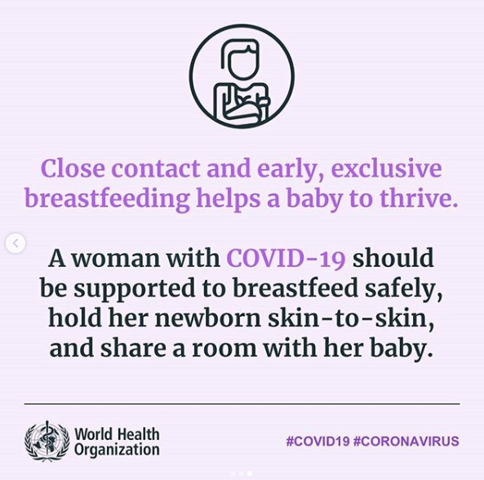

Special considerations: Breastfeeding and COVID-19 positive women
In limited studies on women with COVID-19 and another coronavirus infection, SARS-CoV-2, has not been detected in breast milk; however, data is limited and while it is presumed that breastmilk is not a source of SARS-CoV-2, it has not been confirmed.
Women who are negative for COVID-19 can breastfeed with no restrictions. Please note, however, that women who are asymptomatic should follow the same measures as those who are symptomatic or positive to ensure they minimize any risk to their infant via asymptomatic shedding of the virus.
According to the WHO: Women who are symptomatic or have tested positive for COVID-19 should ensure they maintain a healthy environment for their infants. In the absence of transmission of COVID-19 through breastmilk, there is still a risk that mothers can pass on infections to their infants via other means and must take appropriate measures to avoid this. This includes:
- Practice respiratory hygiene during feeding, wearing a mask where available;
- Wash hands before and after touching the baby;
- Routinely clean and disinfect surfaces they have touched.
If a mother is healthy and can care of her infant, mothers and infants should be enabled to remain together and practice skin-to-skin contact, kangaroo mother care and to remain together and to practice rooming-in throughout the day and night, especially immediately after birth during establishment of breastfeeding, whether they or their infants have suspected, probable or confirmed COVID-19 virus infection.

Please note, that even with the WHO guidelines, it is important to consider separating mother and baby if mother is symptomatic or known positive and there are barriers to performing hygiene measures. This includes lack of running water and soap or hand sanitizer and measures to lower risk of droplet transmission such as lack of masks are unavailable for example. Decisions should be made based on the best information at the time for the safety and health of both mother and baby.

According to the CDC, however, separation of mother and infant may be beneficial to reduce the risk of transmission SARS-CoV-2 from the mother to the newborn via droplet exposure. The risks and benefits of temporary separation of the mother from her baby should be discussed with the mother (or her family if she is not medically stable) by the health care team, and decisions about temporary separation should be made in accordance with the mother’s and/or families wishes as well as the healthcare status of the infant. The decision to initiate and discontinue separation should take into account disease severity, illness signs and symptoms, and results of laboratory testing for the SARS-CoV-2. Throughout the course of temporary separation, all feedings should be provided by a healthy caregiver wearing appropriate PPE (gown, gloves, face, mask and eye protection) if possible.

If a mother is too unwell to breastfeed her baby due to COVID-19 or other complications, she should be supported to safely provide her baby with breastmilk in a way that is possible, available, and acceptable to her and her family. This could include:
- Expressing milk (only if woman is healthy enough to support this)
- Relactation at a later time
- Donor human milk.

Per WHO guidelines there should be no promotion of breastmilk substitutes, feeding bottles and teats, pacifiers or dummies in any part of facilities providing maternity and newborn services, or by any of the staff. Health facilities and their staff should not give feeding bottles and teats or other products within the scope of the International Code of Marketing of Breast-milk Substitutes and its subsequent related WHA resolutions, to breastfeeding infants.
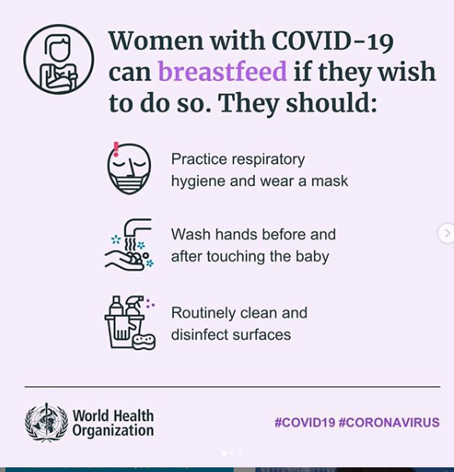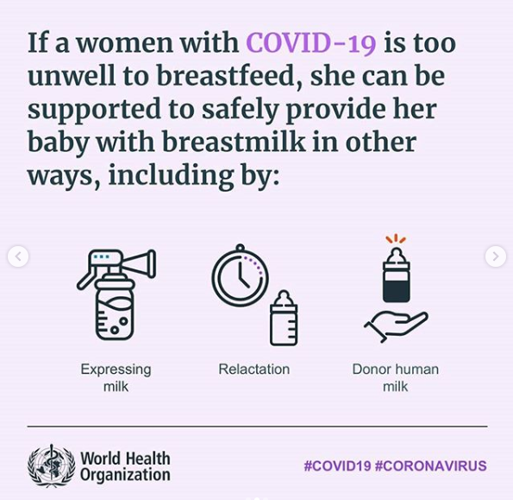

Sources of Information/References

As Coronavirus Looms, Mask Shortage Gives Rise to Promising Approach. Nytimes.com. (2020). Retrieved 26 March 2020, from https://www.nytimes.com/2020/03/20/health/coronavirus-masks-reuse.html.

Baud, D., Giannoni, E., & Pomar, L. (2020). Supplementary webappendix: Covid-19 in Pregnancy. Thelancet.com. Retrieved 26 March 2020, from https://www.thelancet.com/cms/10.1016/S1473-3099(20)30192-4/attachment/fc0d1cfe-8369-4a13-927b-1a7b64a59963/mmc1.pdf.

Berghella, B. (2020). NOW!: Protection for Obstetrical providers and Patients. Ajog.org. Retrieved 28 March 2020, from https://www.ajog.org/coronavirus_guidance_ajog_mfm.

Boelig, R., Manuck, T., Oliver, E., Mascio, D., Saccone, G., Bellussi, F., & Berghella, V. (2020). Labor and Delivery Guidance for COVID-19. Ajog.org. Retrieved 28 March 2020, from https://www.ajog.org/coronavirus_guidance_ajog_mfm.

Breslin, N., Baptiste, C., Miller, R., Fuchs, K., Geoffman, D., Gyamfi-Bannerman, C., & D'Alton, M. (2020). COVID-19 in pregnancy: Early lessons. Ajog.org. Retrieved 27 March 2020, from https://www.ajog.org/coronavirus_guidance_ajog_mfm.

Clinical management of severe acute respiratory infection when novel coronavirus (nCoV) infection is suspected. Who.int. (2020). Retrieved 25 March 2020, from https://www.who.int/publications-detail/clinical-management-of-severe-acute-respiratory-infection-when-novel-coronavirus-(ncov)-infection-is-suspected?fbclid=IwAR3F5ceFqT9yj-jd9_SlPa88EYF6pCHOP2vkW1LH99Rw1c6j6k2-QrJJwlk.

Coronavirus COVID-19 | Evidence Based Birth® Resource Page - Evidence Based Birth®. Evidence Based Birth®. (2020). Retrieved 26 March 2020, from https://evidencebasedbirth.com/covid19/.

CORONAVIRUS (COVID-19) – Guidance for CABC- Accredited Birth Centers. Birthcenteraccreditation.org. (2020). Retrieved 25 March 2020, from https://www.birthcenteraccreditation.org/wp-content/uploads/2020/03/CABC_COVID19Guidance_March2020.pdf?fbclid=IwAR0zD_0M8j_ngHdzYI7BIfBJ5EUwr8Pa3zpmOtSClXU2CSjP10YNq328NZ8.

Coronavirus disease (COVID-19) Advice for the public. Who.int. (2020). Retrieved 26 March 2020, from https://www.who.int/emergencies/diseases/novel-coronavirus-2019/advice-for-public.

Coronavirus Disease (COVID-19) and Breastfeeding. Centers for Disease Control and Prevention. (2020). Retrieved 25 March 2020, from https://www.cdc.gov/breastfeeding/breastfeeding-special-circumstances/maternal-or-infant-illnesses/covid-19-and-breastfeeding.html.

Coronavirus Disease 2019 (COVID-19) Criteria for Return to Work for Healthcare Personnel with Confirmed or Suspected COVID-19 (Interim Guidance). Centers for Disease Control and Prevention. (2020). Retrieved 26 March 2020, from https://www.cdc.gov/coronavirus/2019-ncov/healthcare-facilities/hcp-return-work.html.

Coronavirus Disease 2019 (COVID-19). Healthcare Professionals: Frequently Asked Questions and Answers. Centers for Disease Control and Prevention. (2020). Retrieved 25 March 2020, from https://www.cdc.gov/coronavirus/2019-ncov/hcp/faq.html.

Coronavirus (COVID-19) infection and pregnancy. Royal College of Obstetricians & Gynaecologists. (2020). Retrieved 27 March 2020, from https://www.rcog.org.uk/coronavirus-pregnancy.

Coronavirus Disease 2019 (COVID-19) Interim Considerations for Infection Prevention and Control of Coronavirus Disease 2019 (COVID-19) in Inpatient Obstetric Healthcare Settings. Centers for Disease Control and Prevention. (2020). Retrieved 27 March 2020, from https://www.cdc.gov/coronavirus/2019-ncov/hcp/inpatient-obstetric-healthcare-guidance.html.

Coronavirus Disease 2019 (COVID-19). Interim U.S. Guidance for Risk Assessment and Public Health Management of Healthcare Personnel with Potential Exposure in a Healthcare Setting to Patients with Coronavirus Disease (COVID-19)
Centers for Disease Control and Prevention. (2020). Retrieved 26 March 2020, from https://www.cdc.gov/coronavirus/2019-ncov/hcp/guidance-risk-assesment-hcp.html.

Coronavirus Disease 2019 (COVID-19). Pregnancy and Breastfeeding. Centers for Disease Control and Prevention. (2020). Retrieved 25 March 2020, from https://www.cdc.gov/coronavirus/2019-ncov/prepare/pregnancy-breastfeeding.html.

Coronavirus disease (COVID-19): What parents should know. Unicef.org. (2020). Retrieved 25 March 2020, from https://www.unicef.org/stories/novel-coronavirus-outbreak-what-parents-should-know.

Coronavirus infection and pregnancy. Royal College of Obstetricians & Gynaecologists. (2020). Retrieved 25 March 2020, from https://www.rcog.org.uk/en/guidelines-research-services/guidelines/coronavirus-pregnancy/covid-19-virus-infection-and-pregnancy/?fbclid=IwAR0Ncyovu935FEoZ11D8U46JioR3i5N_A0bR-bBb70rOxewybtccw5f3EyE.

Coronavirus vs. flu: How to tell the difference. Medicalnewstoday.com. (2020). Retrieved 25 March 2020, from https://www.medicalnewstoday.com/articles/coronavirus-vs-flu#severity-and-mortality.

COVID-19: Reduced schedule of visits and use of PPE in midwifery contacts. Ontariomidwives.ca. (2020). Retrieved 28 March 2020, from https://www.ontariomidwives.ca/infectious-diseases.

Davies, A., Thompson, K., Giri, K., Kafatos, G., Walker, J., & Bennett, A. (2020). Testing the efficacy of homemade masks: would they protect in an influenza pandemic? - PubMed - NCBI. Ncbi.nlm.nih.gov. Retrieved 26 March 2020, from https://www.ncbi.nlm.nih.gov/pubmed/24229526.

Dong, L., Tian, J., & He, S. (2020). Possible Vertical Transmission of SARS-CoV-2 From an Infected Mother to Her Newborn. Jamanetwork.com. Retrieved 27 March 2020, from https://jamanetwork.com/searchresults?q=dong%20tian%20he&allSites=1&SearchSourceType=1&exPrm_qqq={!payloadDisMaxQParser%20pf=Tags%20qf=Tags^0.0000001%20payloadFields=Tags%20bf=}%22dong%20tian%20he%22&exPrm_hl.q=dong%20tian%20he
Gawande, A. (2020). mask-ppe-EBM-v1.2-3-25-2020.pdf - Box. M.box.com. Retrieved 26 March 2020, from https://m.box.com/shared_item/https%3A%2F%2Fstanfordmedicine.box.com%2Fv%2Fcovid19-PPE-1-1?fbclid=IwAR2aLRczXcDANTZy07mkkJpiixG95yHfcLTA_rVBlrzHRzhI3ptn7pt5ti0.

Guidance for the Prevention and Control of Influenza in the Peri- and Postpartum Settings | CDC. Cdc.gov. (2020). Retrieved 26 March 2020, from https://www.cdc.gov/flu/professionals/infectioncontrol/peri-post-settings.htm.

Infectious Diseases | AOM. Ontariomidwives.ca. (2020). Retrieved 29 March 2020, from https://www.ontariomidwives.ca/infectious-diseases.

Keeping Waterbirth Safe During COVID-19. Waterbirth International. (2020). Retrieved 29 March 2020, from https://waterbirth.org/keeping-waterbirth-safe-during-covid-19/?fbclid=IwAR3q0-PeUfL727tnaDDF_lMXMQ010qeEqfRZ_Z8Fwpvdg038_adIhgCF080.

McLemore, M. (2020). COVID-19 Is No Reason to Abandon Pregnant People. Scientific American Blog Network. Retrieved 26 March 2020, from https://blogs.scientificamerican.com/observations/covid-19-is-no-reason-to-abandon-pregnant-people/?fbclid=IwAR2uc_Ai-FLUsh4H5esNtcei_XEnOqzEva8N6_2I5ONKsOveOxCg1TJusDc.

Outpatient Assessment and Management for Pregnant Women With Suspected or Confirmed Novel Coronavirus (COVID-19). Acog.org. (2020). Retrieved 27 March 2020, from https://www.acog.org/-/media/project/acog/acogorg/files/pdfs/clinical-guidance/practice-advisory/covid-19-algorithm.pdf?la=en&hash=2D9E7F62C97F8231561616FFDCA3B1A6.

Price, A., & Chu, L. (2020). What are good ways to address the shortage of face masks by anesthesiologists?mask-ppe-EBM-v1.2-3-25-2020.pdf - Box. M.box.com. Retrieved 26 March 2020, from https://m.box.com/shared_item/https%3A%2F%2Fstanfordmedicine.box.com%2Fv%2Fcovid19-PPE-1-1?fbclid=IwAR2aLRczXcDANTZy07mkkJpiixG95yHfcLTA_rVBlrzHRzhI3ptn7pt5ti0.

Price, A and Chu LF, March (2020), COVID-19 Addressing COVID-19 Face Mask Shortages (v 1.3), Learnly Anesthesia/Stanford AIM Lab COVID-19 Evidence Service, Stanford, California USA. Retrieved 26 March 2020 from https://m.box.com/shared_item/https%3A%2F%2Fstanfordmedicine.box.com%2Fv%2Fcovid19-PPE-1-2

Q&A on COVID-19, pregnancy, childbirth and breastfeeding. Who.int. (2020). Retrieved 25 March 2020, from https://www.who.int/news-room/q-a-detail/q-a-on-covid-19-pregnancy-childbirth-and-breastfeeding.

Rational use of personal protective equipment for coronavirus disease 2019 (COVID-19). Apps.who.int. (2020). Retrieved 25 March 2020, from https://apps.who.int/iris/bitstream/handle/10665/331215/WHO-2019-nCov-IPCPPE_use-2020.1-eng.pdf.

Rupsa, C., Boelig, R., Saccone, G., Bellussi, F., & Berghella, V. (2020). MFM Guidance for COVID-19. Retrieved 25 March 2020, from https://www.sciencedirect.com/science/article/pii/S2589933320300367.

UpToDate. Uptodate.com. (2020). Retrieved 26 March 2020, from https://www.uptodate.com/contents/coronavirus-disease-2019-covid-19?source=history_widget.

Waterbirth and hydrotherapy for pregnant people with suspected or confirmed COVID-19. Ontariomidwives.ca. (2020). Retrieved 29 March 2020, from https://www.ontariomidwives.ca/infectious-diseases.

What's the difference between a cold, the flu, and coronavirus?. intermountainhealthcare.org. (2020). Retrieved 25 March 2020, from https://intermountainhealthcare.org/blogs/topics/live-well/2020/03/whats-the-difference-between-a-cold-the-flu-and-coronavirus/.

Appendix A: Definitions and Acronyms:

CDC: Centers for Disease Control and Prevention. A US based health protection agency.

COVID-19: Short for Coronavirus Disease 2019. It’s the official name of the disease caused by SARS-CoV-2. CO (Corona) VI (Virus) D (Disease) - 19 (2019)

HCP: Health care provider or Health care personnel

HCW: Health care worker

nCoV: novel coronavirus - a new coronavirus

PPD: Postpartum depression

PPE: Personal protective equipment including but not limited to masks, gloves, gowns, respirators

SARS-CoV-2: The official scientific name of the coronavirus causing the pandemic. It stands for severe acute respiratory syndrome coronavirus 2. It was previously known as 2019-nCoV.

URI: Upper respiratory infection which include symptoms of: coughing, discomfort in the nasal passages, mild fever, which is more common in children, excess mucus, nasal congestion, pain or pressure behind the face, a runny nose, a scratchy or sore throat, sneezing

WHO: World Health Organization - International public health agency whose core function is to direct and coordinate international health work through collaboration.

Epidemic: An outbreak that has spread to a wider area.

Isolation: When someone who is definitely sick stays away from others so that they don’t infect anyone else. In the case of this coronavirus, isolation should continue until the risk of infecting someone else is thought to be low. The current guidelines for SARS-CoV-2 recommend isolation for at least 7 days from the first symptom and for 72 hours since the last symptom has passed.

Close contact: In the case of COVID-19, it’s anyone who is within 6 feet of a person infected with SARS-CoV-2 for a prolonged period of time (CDC does not give a definitive definition but states that they consider a prolonged period of time anything more than a few minutes). This includes people who live with, care for or visit an infected person. It can also describe people who merely share a waiting room with an infected patient or who have direct contact with a patient’s infectious secretions (such as by being coughed on).

Community spread: When an infectious disease is spreading in an area and the people who are contracting it don’t know where or how they caught it. It’s an indication that a virus is no longer contained to a limited number of people.

Containment: A public health strategy in which officials aim to prevent the spread of an infectious disease beyond a small group of people to the broader community. Containment actions include restricting travel from affected regions, identifying infected people and tracking down everyone they live with or have spent time with (contact tracing), and asking those who have been exposed to the virus to stay at home for a period of time. Although it did not work for COVID-19, containment has been used to keep a measles outbreak from spreading out of control within communities with low immunization, for instance.

Mitigation: The public health goal once a virus has spread so widely that it’s impossible to keep it away. Instead of mainly relying on public health authorities to do things like locate sick people and identify their contacts, health officials ask the public to help slow the spread of the virus. Useful actions can include reminding people to stay home when they’re sick and disinfecting commonly touched surfaces in buildings daily. One of the main strategies is to practice “social distancing.”

Outbreak: An increase, often sudden, in the number of cases of a disease above what is normally expected among the population in a limited area.

Pandemic: An epidemic that has spread over multiple countries or continents, usually affecting a large number of people. SARS-CoV-2 was declared a pandemic by the WHO on March 11, 2020.

Prolonged contact/exposure: According to the CDC, data are insufficient to precisely define the duration of time that constitutes a prolonged exposure. However, until more is known about transmission risks, it is reasonable to consider an exposure greater than a few minutes as a prolonged exposure.

Quarantine: When someone who has been exposed to a disease but is not visibly sick stays away from others for a period of time in case they are infected. By keeping their distance, they can avoid spreading the disease to others. A quarantine usually lasts a little longer than the incubation period for a disease, just to be safe. The current guidelines for SARS-CoV-2 recommend quarantine for a period of 14 days.

Social distancing: Measures designed to keep people away from crowded places where a virus could more easily spread. In the case of SARS-CoV-2, health officials are encouraging members of the public to work from home, cancel mass events and maintain about six feet of
space between themselves and others. A radical measure is to close most businesses and order the public to shelter at home except for essential activities, such as purchasing food and caring for relatives, while allowing people to go outside for a walk.

Appendix B: Rational use of personal protective equipment (PPE) for coronavirus disease (COVID-19) WHO (2020)
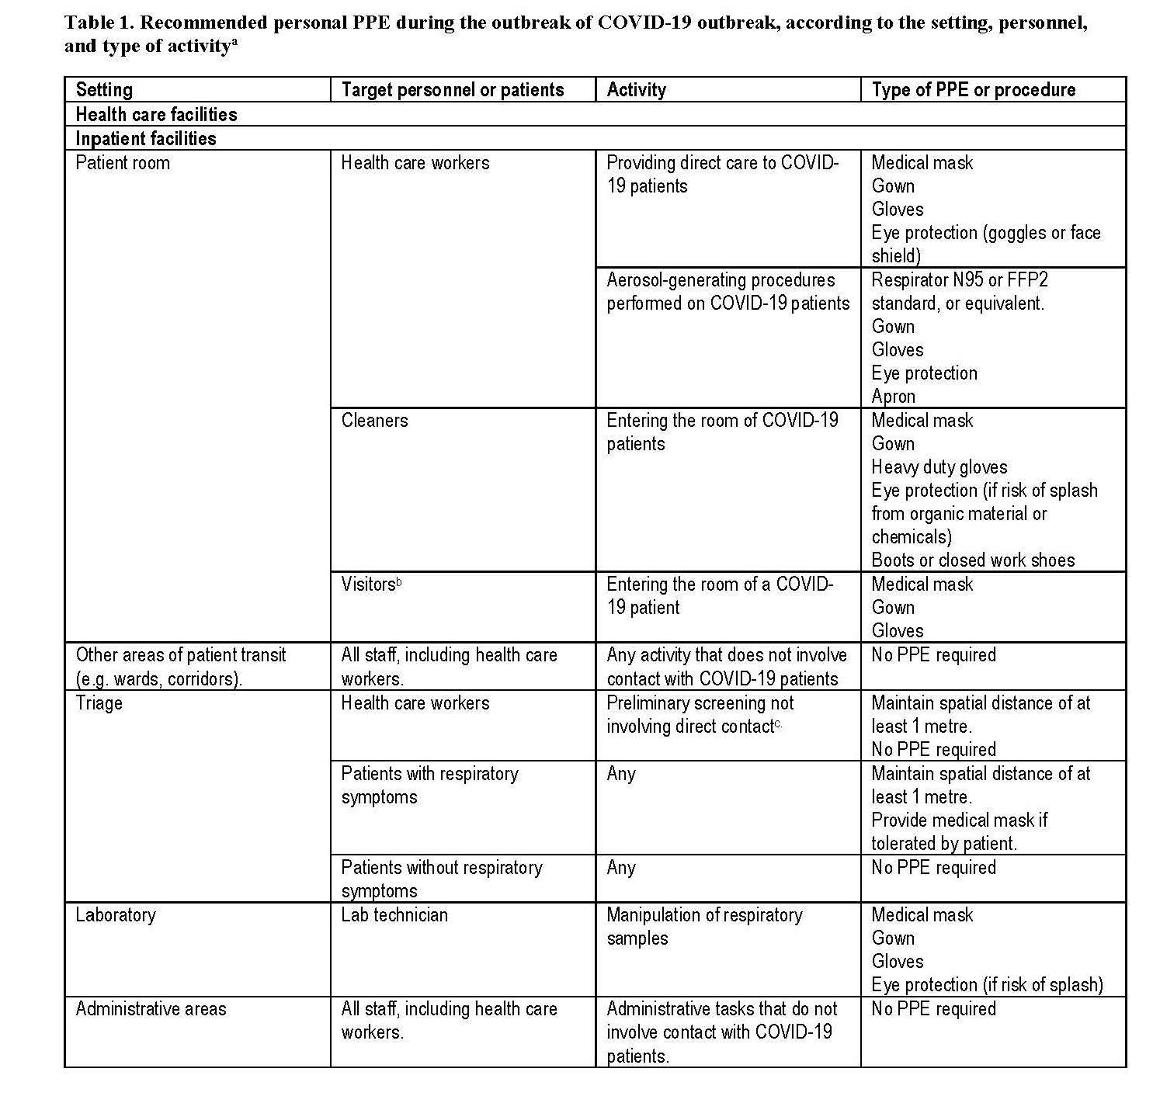
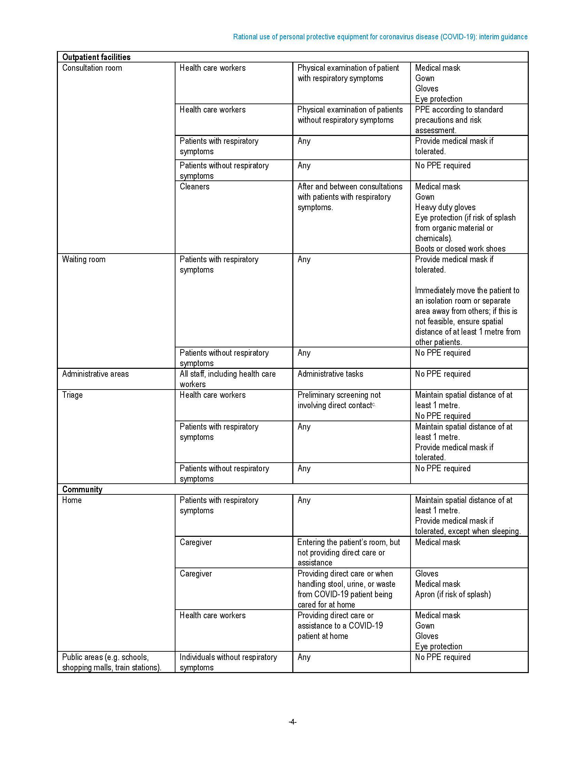
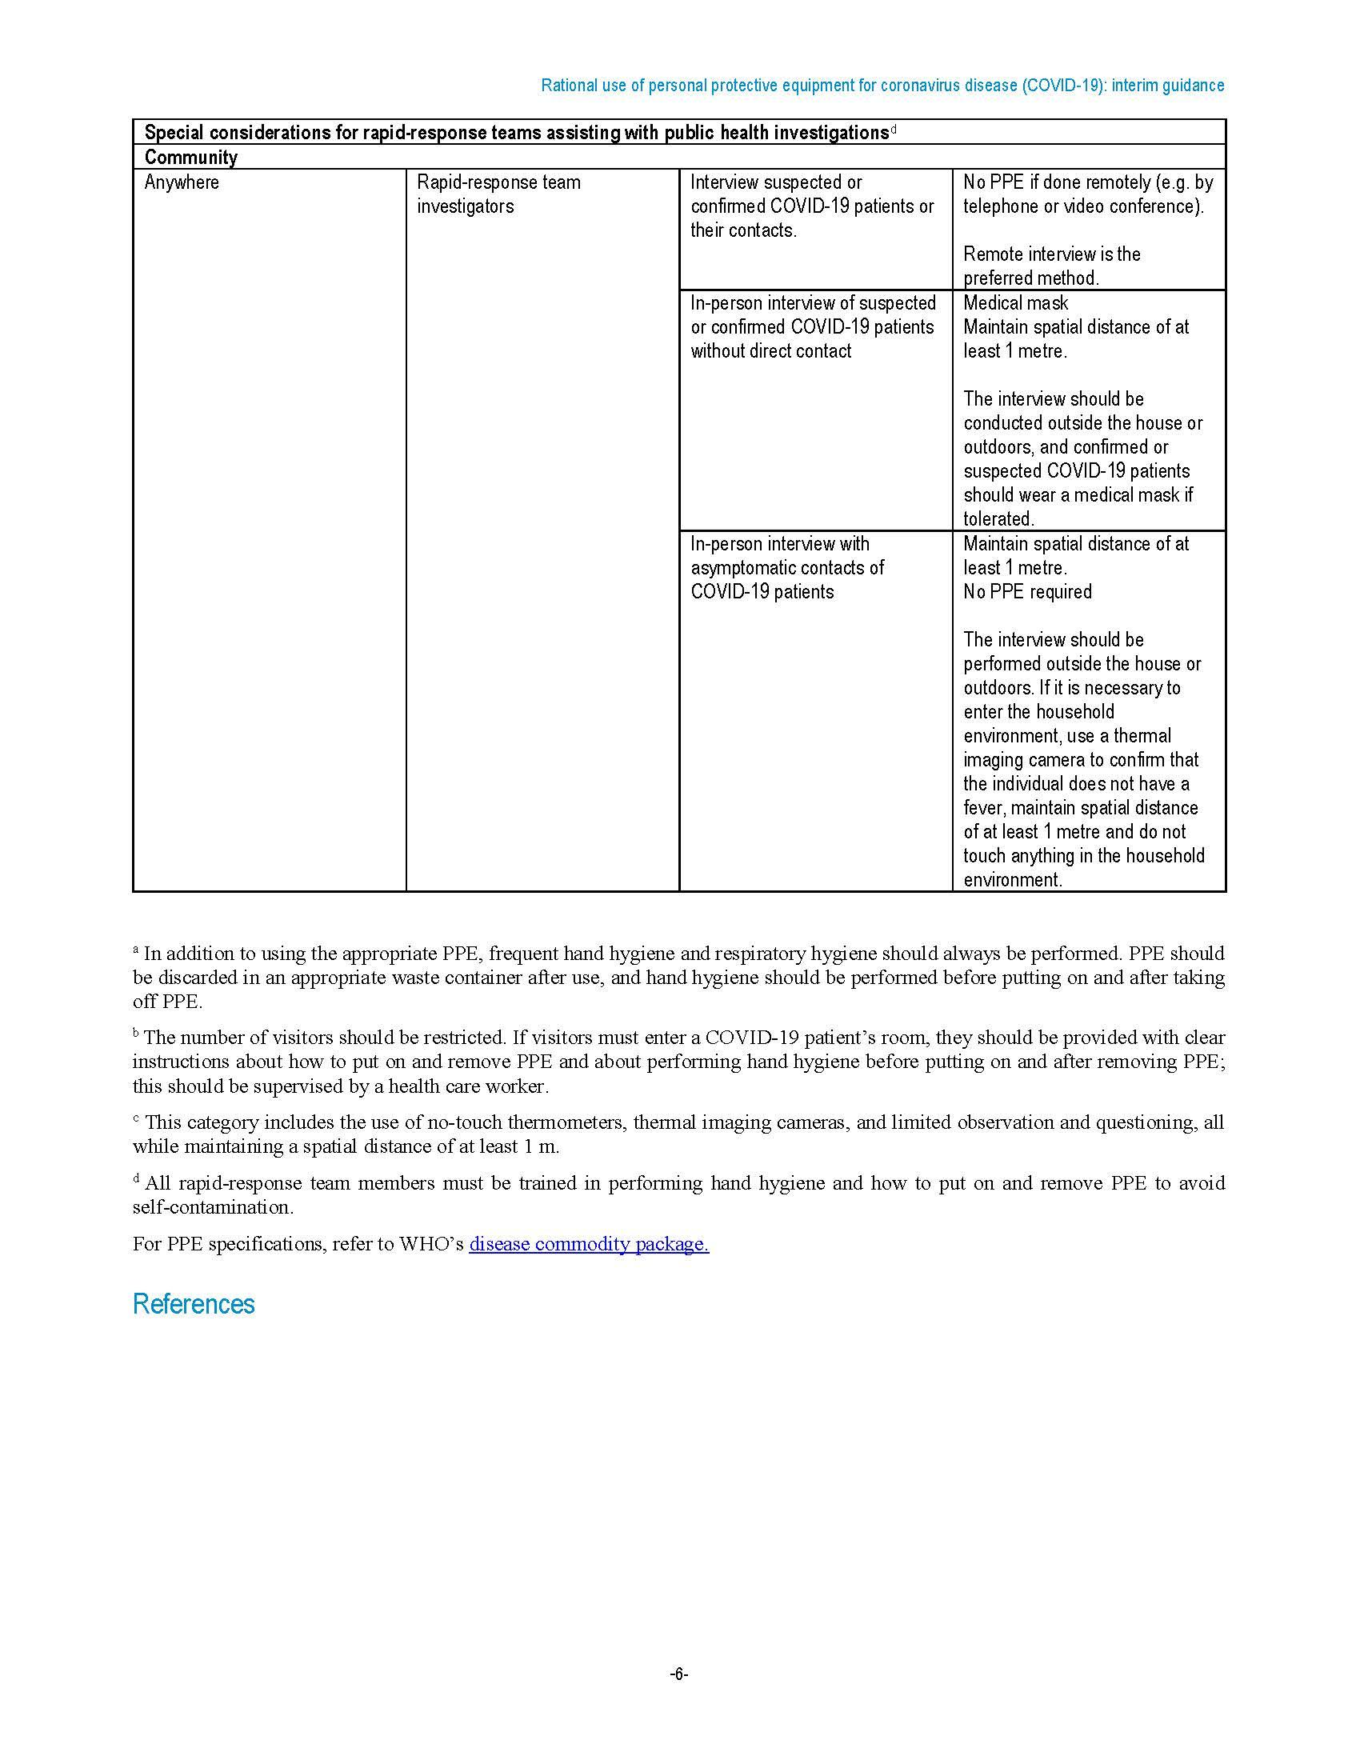
Appendix C: CDC Interim U.S. Guidance for Risk Assessment and Public Health Management of Healthcare Personnel with Potential Exposure in a Healthcare Setting to Patients with Coronavirus Disease (COVID-19)

Self-monitoring: HCP should monitor themselves for fever by taking their temperature twice a day and remain alert for respiratory symptoms (e.g., cough, shortness of breath, sore throat).
Active monitoring: the state or local public health authority assumes responsibility for establishing regular communication with potentially exposed people to assess for the presence of fever or respiratory symptoms
Self-Monitoring with delegated supervision in a healthcare setting: HCP perform self-monitoring with oversight by their healthcare facility’s occupational health or infection control program in coordination with the health department of jurisdiction, if both the health department and the facility are in agreement.
Close contact for healthcare exposures:
- being within approximately 6 feet (2 meters), of a person with COVID-19 for a prolonged period of time (such as caring for or visiting the patient; or sitting within 6 feet of the patient in a healthcare waiting area or room); OR
- having unprotected direct contact with infectious secretions or excretions of the patient (e.g., being coughed on, touching used tissues with a bare hand).
Prolonged exposure: Data are insufficient to precisely define the duration of time that constitutes a prolonged exposure. However, until more is known about transmission risks, it is reasonable to consider an exposure greater than a few minutes as a prolonged exposure.
Brief interactions: briefly entering the patient room without having direct contact with the patient or their secretions/excretions, brief conversation at a triage desk with a patient who was not wearing a facemask.
Healthcare Personnel: HCP refers to all paid and unpaid persons serving in healthcare settings who have the potential for direct or indirect exposure to patients or infectious materials. For this document, HCP does not include clinical laboratory personnel.

Defining Exposure Risk Category:
High-risk exposures: Prolonged close contact with patients with COVID-19 who were not wearing a facemask while HCP nose and mouth were exposed to material potentially infectious with the virus causing COVID-19. Being present in the room for procedures that generate aerosols or during which respiratory secretions are likely to be poorly controlled (e.g., cardiopulmonary resuscitation, intubation, extubation, bronchoscopy, nebulizer therapy, sputum induction) on patients with COVID-19 when the healthcare providers’ eyes, nose, or mouth were not protected, is also considered high-risk.
Medium-risk exposures: Prolonged close contact with patients with COVID-19 who were wearing a facemask while HCP nose and mouth were exposed to material potentially infectious with the virus causing COVID-19.
Low-risk exposures: brief interactions with patients with COVID-19 or prolonged close contact with patients who were wearing a facemask for source control while HCP were wearing a face mask or respirator. Use of eye protection, in addition to a face mask or respirator would further lower the risk of exposure.
No identifiable risk: No direct patient contact and no entry into active patient management areas who adhere to routine safety precautions do not have a risk of exposure to COVID-19.
Epidemiologic risk factors | Exposure category | Recommended Monitoring for COVID-19 (until 14 days after last potential exposure) | Work Restrictions for Asymptomatic HCP
Prolonged close contact with a COVID-19 patient who was wearing a facemask (i.e., source control)
HCP PPE: None | Medium | Active | Exclude from work for 14 days after last exposure
HCP PPE: Not wearing a face mask or respirator | Medium | Active | Exclude from work for 14 days after last exposure
HCP PPE: Not wearing eye protection | Low | Self with delegated supervision | None
HCP PPE: Not wearing gown or gloves | Low | Self with delegated supervision | None
HCP PPE: Wearing all recommended PPE (except wearing a facemask instead of a respirator) | Low | Self with delegated supervision | None
Prolonged close contact with a COVID-19 patient who was not wearing a face mask (i.e., no source control)
Epidemiologic risk factors | Exposure category | Recommended Monitoring for COVID-19 (until 14 days after last potential exposure) | Work Restrictions for Asymptomatic HCP
HCP PPE: None | High | Active | Exclude from work for 14 days after last exposure
HCP PPE: Not wearing a face mask or respirator | High | Active | Exclude from work for 14 days after last exposure
HCP PPE: Not wearing eye protection | Medium | Active | Exclude from work for 14 days after last exposure
HCP PPE: Not wearing gown or gloves | Low | Self with delegated supervision | None
HCP PPE: Wearing all recommended PPE (except wearing a facemask instead of a respirator) | Low | Self with delegated supervision | None

Additional Considerations and Recommendations:
Facilities should develop a plan for how they will screen for symptoms and evaluate ill HCP. This could include having HCP report absence of fever and symptoms prior to starting work each day.
Facilities could consider allowing asymptomatic HCP who have had an exposure to a COVID-19 patient to continue to work after options to improve staffing have been exhausted and in consultation with their occupational health program. These HCP should still report temperature and absence of symptoms each day prior to starting work. Facilities could have exposed HCP wear a facemask while at work for the 14 days after the exposure event if there is a sufficient supply of face masks. If HCP develops even mild symptoms consistent with COVID-19, they must cease patient care activities, don a facemask (if not already wearing), and notify their supervisor or occupational health services prior to leaving work.

Appendix D: Criteria for Return to Work for Healthcare Personnel with Confirmed or Suspected COVID-19 (Interim Guidance)
Use one of the below strategies to determine when HCP may return to work in healthcare settings
- Test-based strategy. Exclude from work until
  - Resolution of fever without the use of fever-reducing medications and
  - Improvement in respiratory symptoms (e.g., cough, shortness of breath), and
  - Negative results of an FDA Emergency Use Authorized molecular assay for COVID-19 from at least two consecutive nasopharyngeal swab specimens collected ≥24 hours apart (total of two negative specimens)
2. Non-test-based strategy. Exclude from work until
  - At least 3 days (72 hours) have passed since recovery defined as resolution of fever without the use of fever-reducing medications and improvement in respiratory symptoms (e.g., cough, shortness of breath); and,
  - At least 7 days have passed since symptoms first appeared
If HCP were never tested for COVID-19 but have an alternate diagnosis (e.g., tested positive for influenza), criteria for return to work should be based on that diagnosis.

Return to Work Practices and Work Restrictions
After returning to work, HCP should:
- Wear a facemask at all times while in the healthcare facility until all symptoms are completely resolved or until 14 days after illness onset, whichever is longer
- Be restricted from contact with severely immunocompromised patients (e.g., transplant, hematology-oncology) until 14 days after illness onset
- Adhere to hand hygiene, respiratory hygiene, and cough etiquette in CDC’s interim infection control guidance (e.g., cover nose and mouth when coughing or sneezing, dispose of tissues in waste receptacles)
- Self-monitor for symptoms, and seek re-evaluation from occupational health if respiratory symptoms recur or worsen

Crisis Strategies to Mitigate Staffing Shortages
Healthcare systems, healthcare facilities, and the appropriate state, local, territorial, and/or tribal health authorities might determine that the recommended approaches cannot be followed due to the need to mitigate HCP staffing shortages. In such scenarios:
- HCP should be evaluated by occupational health to determine appropriateness of earlier return to work than recommended above

- If HCP return to work earlier than recommended above, they should still adhere to the Return to Work Practices and Work Restrictions recommendations above.

Appendix F: Other considerations for masks and PPE - Reusing and Sterilization:
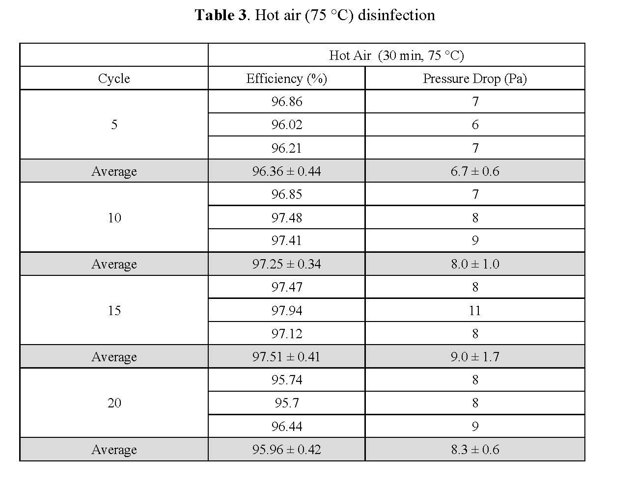
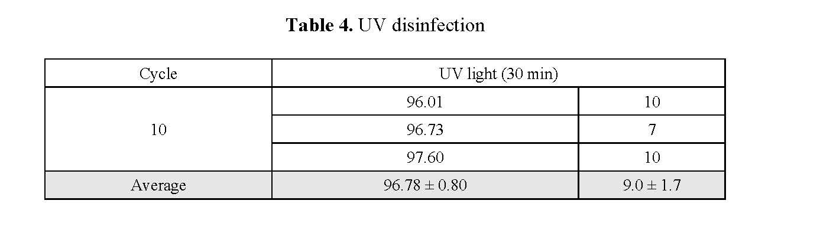
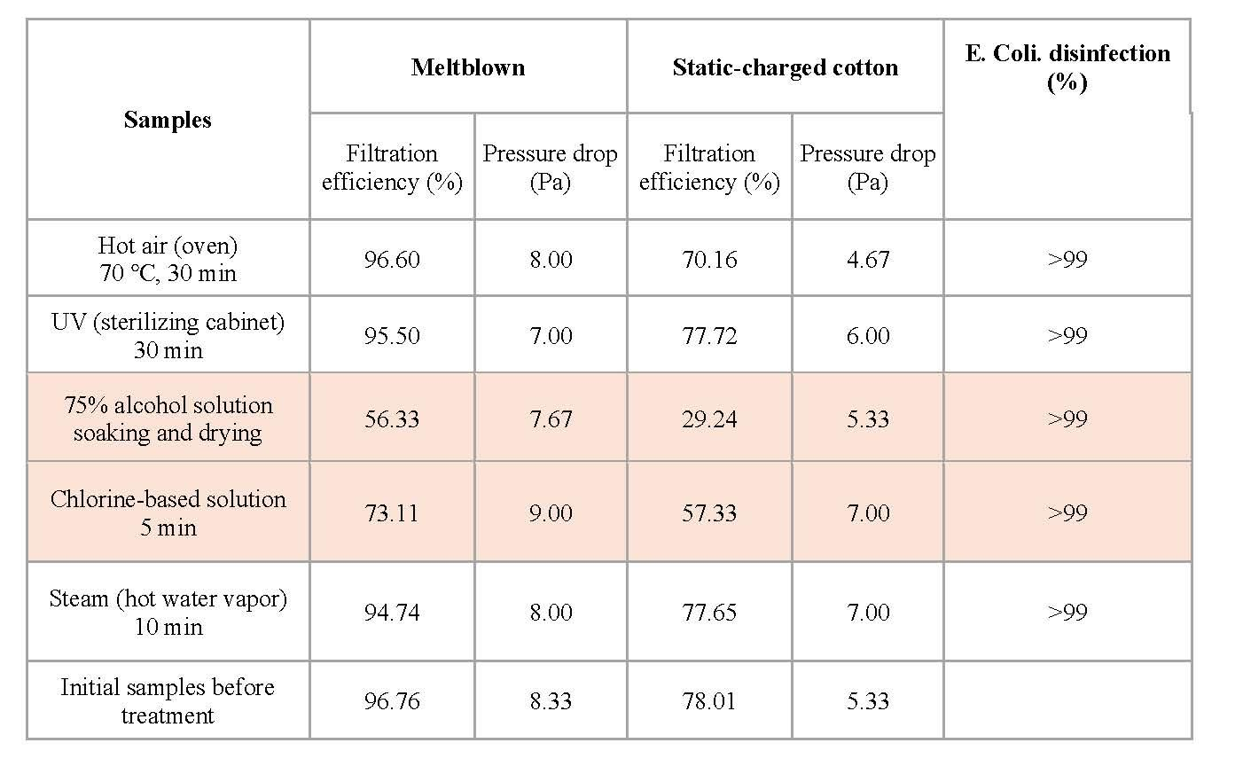
Price and Chu (2020): Conclusion and Additional Notes From our results, there are two disinfection methods which do not reduce the filtration efficiency of the melt blown layer after an appreciable number of treatment cycles. We found: Method 1: 75 °C Hot air (30 min) for 20 cycles Method 2: UV (254 nm, 8 W, 30 min) for 10 cycles. Regarding treatment with steam, we advise caution. For 3 treatment cycles or less, we found the filtration efficiency can be maintained at >95%. However, after 5 cycles the efficiency drops to ~85%, and 10 cycles will drop the efficiency to ~80%

